Redeemer Announcements – May 22, 2022

Our Mission
Gather, Grow, and Go
to the Glory of God

Sun 8:00 AM The Church Gathers for
Worship
9:15 AM Congregational Open Forum
10:30 AM The Church Gathers for
Worship
4:00 PM WLA Spring Concert at Buttermilk Park
Mon 6:30 PM The Church Gathers for
Worship
Tues 6:30 PM Ladies Society
Thur 10:00 AM Kindergarten Graduation
6:30 PM Ascension/Graduation Service
Fri 7:00 AM Faculty Meeting
Sat 10:00 AM WLA Graduation
Sun 8:00 AM The Church Gathers for
Worship
10:30 AM The Church Gathers for
Worship

SERVING TODAY
Organist Sunday: Stephanie Ehlke
Pianist Monday: Lilly Muche
Preacher: Pastor James Borgwardt
Liturgist: Pastor Chris Rathje
Cantor: Naomi Schmidt

GATHERING FOR WORSHIP

Sunday 15th 8:00am: 178
10:30am: 87
Monday 16th 6:30pm: 25
Total: 290

OPEN FORUM – Today, May 22 at 9:15 AM, we will gather in the sanctuary for an important update on our Facility Expansion Research. We’ll need the large sanctuary space to fit the attendees. We’ll have extra chairs ready for an overflow crowd. Childcare will be provided in the gymnasium.

== GATHERING for Worship and Fellowship ==
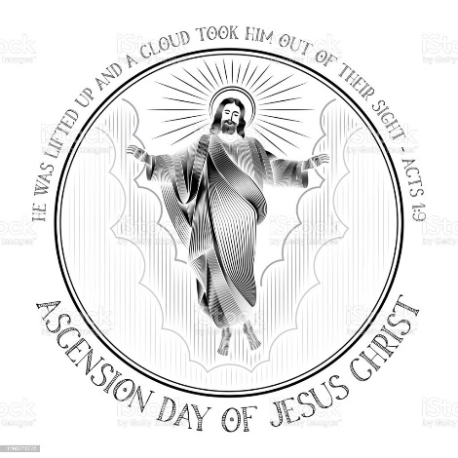
ASCENSION WORSHIP—A favorite service for many, our annual Ascension service features devotions along with choir anthems from the grade school children and Senior choir that remind us of the blessings we enjoy from our Ascended Savior. It is this Thursday, May 26th at 6:30 pm. We will also recognize our 8th grade graduates from Redeemer School.
BEGINNING JUNE 5 we will switch to our summer worship schedule. The 10:30 Sunday service will be moved to 9:30.
Weather-permitting, the 9:30 am service on the last Sunday of the month, June through September, will be held outside on the lawn.
ELECTRONIC GIVING UPDATE – As of May 1st, the GivePlus Mobile app has been replaced with Vanco Mobile. For those who already have automatic payments set up for their giving, no action is needed for those payments to continue as scheduled. However, if wish to make changes to your automatic payments in the future or if you would like to set up automatic payments for the first time, you will need to use the Vanco Mobile app. It is available in the Apple App Store and Google Play Store. Once downloaded, search “Fond du Lac” and scroll down to Redeemer. The login credentials remain the same from the GivePlus Mobile app. You may also manage e-giving through our church website, redeemerfdl.org. Find Church ===> Giving in the menu bar and then click on “Give a Gift.”

== GOING to Witness Christ & Serve Others ==
SOCCER CAMP— Monday-Thursday, June 20-23, 2022. Ages 4yr-12yr olds may attend. Registration is open on our website today for an early bird special of $20/camper. On June 1, $30/camper will be the fee. Payment options this year include online or in-person. Your child’s spot is reserved upon receiving payment. Spots fill quickly!

We always need many 7th through 12th grade helpers and coaches to make our camp a success. Plenty of adult volunteers also make our camp run well. Look for sign-up sheets on our bulletin boards.
PRO-LIFE LIVING– Our Christian calling includes supporting all life and serving all people – both protecting the lives of unborn babies and serving souls who struggle with crisis pregnancies. We have many opportunities to care for moms and children after delivery. One ministry is called WELS Lutherans for Life. A recent newsletter highlighting their Pro-Life ministry to mothers and their children can be found by the office window.
TASTE OF MISSIONS – Join your brothers and sisters in Christ from around the world for Taste of Missions, a hybrid event that will be held on Saturday, June 11, 2022, at Wisconsin Lutheran Seminary in Mequon, WI. Join us in person OR online to get a “taste of missions” no matter where you might be around the world. Registration is $15 per person, with children 13 and under attending for free. Those attending in person will receive food tickets to sample ethnic food and will have the ability to purchase additional food from the food trucks. Or attend virtually for free! Find more details at tasteofmissions.com.
HOST FAMILIES NEEDED – WLA is looking for host families for international students for the 2022-23 school year. There have been several students who’ve requested to attend WLA who we’ve been unable to accept because we didn’t have a host for them. If you’re interested in opening your home to a high school student from another country - what a great opportunity to share your faith! - or if you just have questions, please contact Kristin Mose (kmose@wlavikings.org). Host families are provided a stipend each month for room and board.
===========================================
TEE IT UP FOR WLA will be held on Friday, June 24 at Whispering Springs Golf Course. Shotgun start at 10:00 am and includes 18 hole scramble with cart, range, beverages, lunch and dinner. Funds raised are used to provide over
$100,000 annually in tuition assistance to families in need. To register visit the WLA
website at wlavikings.org and click on the support tab for fundraising events.

WLA SPRING CONCERT will be held at Buttermilk Creek Park today, May 22, beginning at 4:00 pm. Join the WLA choir and band for an afternoon filled with music. Bring your own lawn chair or blanket. Please don’t bring pets! In case of rain, the concert will be held in the WLA Gymnasium.

COMMENCEMENT CELEBRATIONS – Congratulations to all of our members who finished their courses of study at the college level. Three of our members graduated last Winter: Rachel Meihack from the University Wisconsin-La Crosse; Erin Belling from Concordia University-Wisconsin; and Jena Krueger from the University of Wisconsin-Green Bay.
This month saw the graduations of the following: Olivia Livieri and Roman Muche Fox Valley Tech; Brianna Bakri from Wisconsin Lutheran College; Erik Nygaard from Michigan State University; Sam Schmitz from St Olaf University; Anna Erdmann from Northeast Wisconsin Tech; Luke Meihack from Martin Luther College; and Tess Cederholm with an advanced degree from Carroll University
MINISTRY ASSIGNMENTS – Tyler Roecker is completing his second year in his original assignment as a tutor at Luther Preparatory School. At MLC Call Day last Saturday, he received a permanent call to Shoreland Lutheran Academy in Sommers, Wisconsin. Luke Meihack also received an assignment on Call Day. He will serve at Kettle Moraine Lutheran High School in Jackson, Wisconsin.
Congratulations to all!

